

1/ Answer:

The man is standing next to the whiteboard.

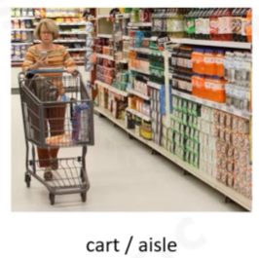

2/ Answer:

The woman is pushing a shopping cart on the aisle.

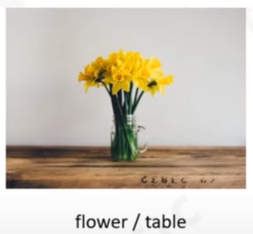

3/ Answer:

There are some flowers on the table.



4/ Answer:

Although the weather is cold, the woman is walking barefoot.



If the football player scores the goal, his team will win the match.

(If the soccer player scores the goal, his team will win the match.)

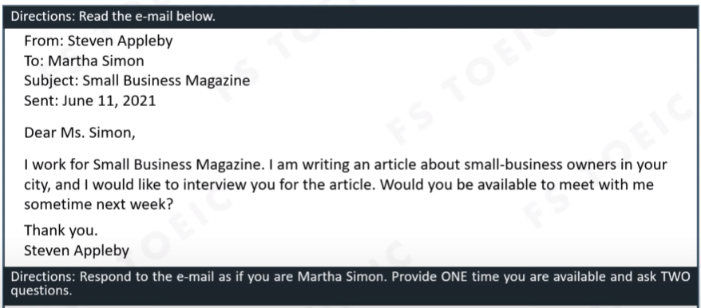

6/ Answer:

Dear Mr. Appleby,

Thank you for contact with me. I am writing in response to your email dated June 11th regarding your interview me for the article.

I can be available to meet with you from 6PM to 8PM on June 14th and June 15th .

I have got two questions for you. First, how many things what do you want to interview me? Second, I want to know why you choose me to interview with you? I hope you will answer my question.

I’m looking forward to hearing from you.

Best regards,

Martha Simon

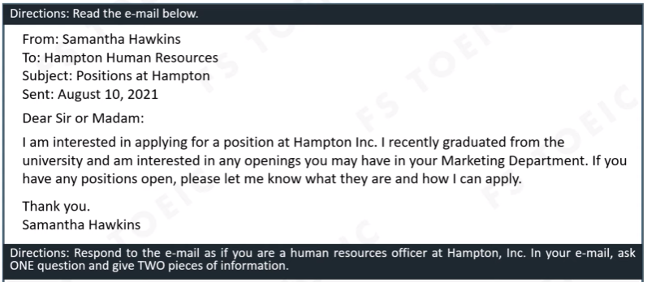

7/ Answer:

Dear Mrs. Hawskins,

Thank you for choosing Hampton Inc to work. My name is Rony and I am a person in Hampton Human Resources. I am writing in response to your email dated August 10th regarding your applying position in our company.

I have a question for you that there are many companies outside. So why do you choose The Hampton Inc. We have vacant positions at Marketing Media and Marketing Social. If you want to apply at these postions, you will need to have experience about them. You need to have experience in writing, and have a lot of ideas. I hope you got all of conditions.

I’m looking forward to hearing from you.

Best regards,

Rony

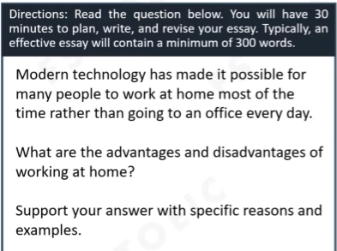

8/ Answer:

There are many advantages and disadvantages of working at home.

About the advantages, first, you can work whenver you want. You can easy to relax whenver you want. Because when you stay at home, no one can follow you, and no one can check what you are doing. Second,

About the disadvantages, first, because you can work whenever you want. So that will make you lazy more than when you work at the office. No one can check what are you doing. So that you can play game, watch TV, do your household,… when you are in working times.